**49.How to build logistic regression model for train data set using python?**

**Objective:**

* To build a logistic regression model for given data set in python.

**Process:**

* Import libraries.
* Read the sample data.
* Define X and y variables.
* Build the logistic regression model.
* Split the sample data into training and test data.
* Fit the training data into the regression model.

**Input:**

* Data set(csv file).

**Output:**

* Summary of logistic regression model for training data.

**Source code:**

#import libraries

import statsmodels.api as sm

import pandas as pd

from sklearn.model_selection import train_test_split

#read the data set

data=pd.read_csv('/home/soft27/soft27/Sathish/

Pythonfiles/Employee.csv')

#creating data frame

df=pd.DataFrame(data)

print(df)

#assigning the independent variable

X = df[['rating','bonus']]

#assigning the dependent variable

y = df['logo']

#split data in training and test data

X_train, X_test, y_train, y_test = train_test_split(X, y, test_size=0.3, random_state=0)

print(X_train)

print(y_train)

#build the model

model = sm.Logit(y_train, X_train)

#fit the model

result = model.fit()

#take summary of model

print(result.summary())

#print the confidence interval

print("The confidence interval is",result.conf_int())

**Screen shot:**

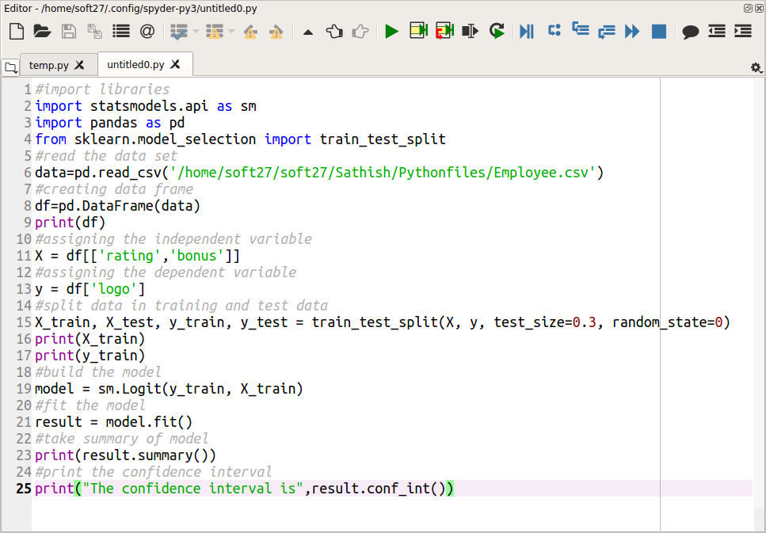

**Output:**

